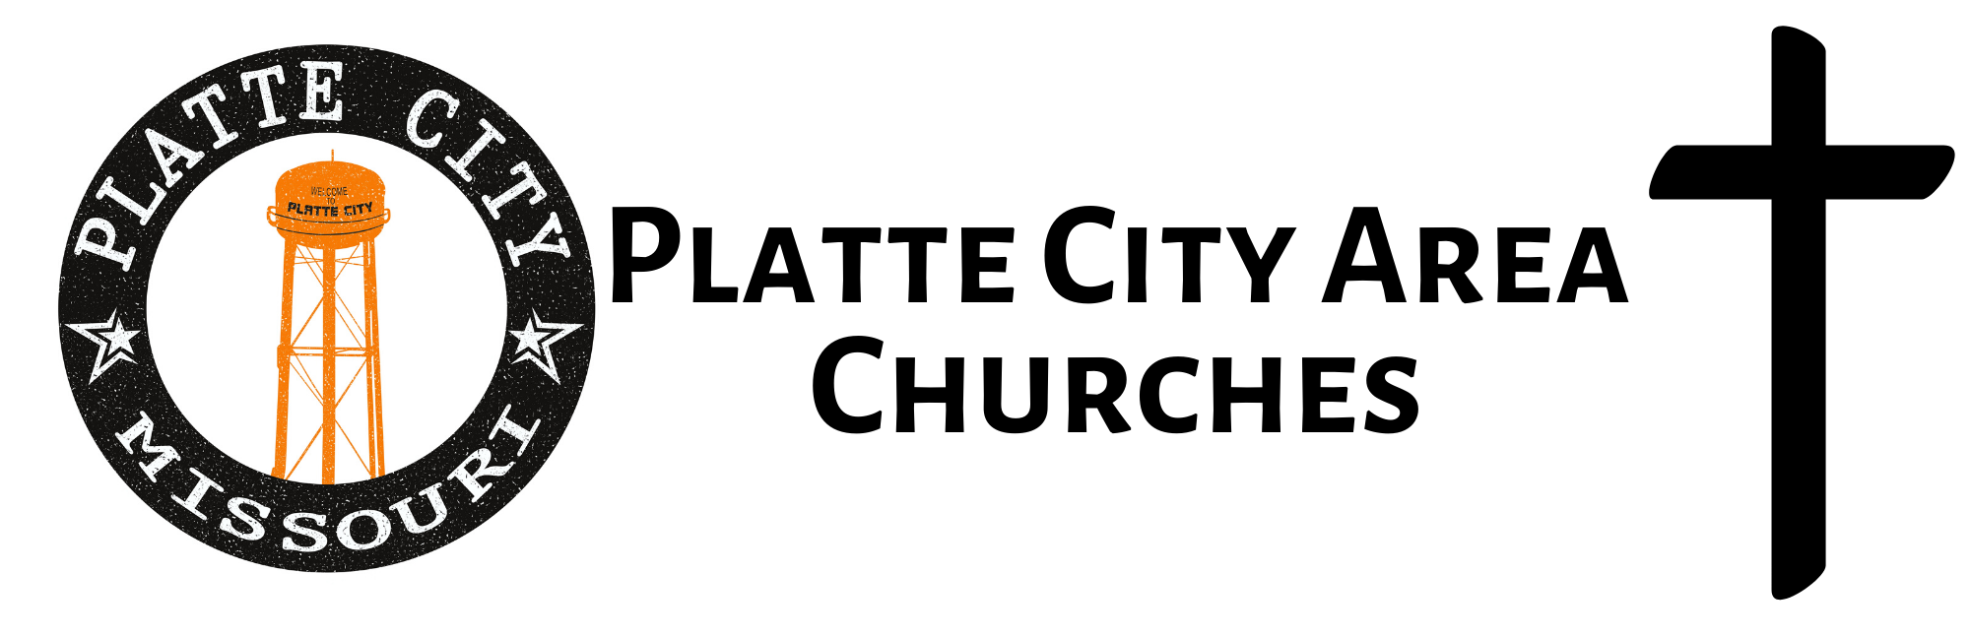
Beacon of Hope
www.bohpc.com
816.500.3784

Bethel House of Prayer
1221 Branch St
www.bethelhouseofprayer.com
816.903.PRAY

Christ Chapel Assembly
15275 Highway 92
www.christchapelpc.com
816.858.5416

First Baptist Church
214 Ferrel Street
www.fbcplattecity.com
816.858.2018

First Christian Church
Corner of 3rd St. & Ferrel St.
fccpc@uniteone.net
816.858.2000

Hillsboro Christian Church
10005 Hillsboro Road
www.hillsborochurchonline.com
816.330.3823

Hoover Christian Church
15180 B Highway
www.hooverchristianchurch.com
816.699.2363

Jehovah’s Witness
8105 NW 92 Highway
816.270.0500

New Life Baptist Church
7 Atchison Ct
816.858.4092
cejohnson008@yahoo.com

Our Savior Lutheran Church (LCMS)
14155 N Highway
www.oursavior-plattecity.org www.oursavioracademy.org
816.335.4049 Church Office
816.866.1597 Christian Academy

Platte City Church of Christ
700 Branch St
816.885.7134

Platte City United Methodist
14040 N Hwy (south 4th St)
www.plattecityumc.com
816.858.2441

Platte Valley Baptist Church
308 Zed Martin Street
816.456.8912

Second Baptist Church
301 N. 3rd Street
secondbaptist77@yahoo.com
816.858.3677

The Calling Community Church
2901 Williamsburg Terrace
816.431.6461
www.thecallingcommunitychurch.com

The Church of Jesus Christ
of the Latter Day Saints
2700 Ensign Dr.
816.824.0699

The Rock of KC
12750 N Winan Road
www.rockofkc.com
816.243.1400

Tracy Baptist Church
207 Andy in Tracy, MO
816.858.2589

Twelve Apostles Catholic Church
17900 Humphreys Rd
Platte City
www.twelveapostlescatholic.org
816.640.2206

